Sport and coaching CV
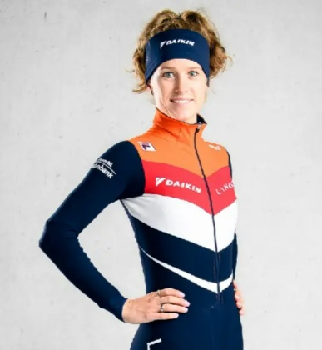
Name: Rianne de Vries
Nationality: Dutch
Languages: Dutch, English
Career highlights

ISU World Cup Competitor (2012– 2023)
World Cup Medals
- Multiple medals in relay events (2000m mixed relay and 3000m Women’s Relay)
- Podium finishes in individual 1500m and 1000m races
European Championships
- European champion 500m, 2017
- Multiple Gold, Silver and bronze medals in relay
World Championships
- World champion, silver and bronze medals in relay.
- Individual finalist
Olympic games
- Sochi (2014), Pyeongchang (2018), Beijng (2022)

Education
- Cios, ice and skate sport
- Certified Level 3 & 4 Speed Skating Coach – longtrack
- Certified Level 3 & 4 Speed Skating Coach – Shorttrack

Coach experience
- Assistant- coach Gewest Fryslân, Longtrack (June 2023 – March 2023)
- Assistant-coach Center of Excellence, shorttrack (July 2024 – present)

